RECOGNISE PRIOR LEARNING (RPL) KIT (Student Guide)

Unit code and name: bsbtec303 cREATE ELECTRONIC PRESENTATIONS

Candidate assessment instructions

SAFETY AND SAFETY RESPONSIBILITIES
While the Assessor is responsible for the safety and welfare of students during assessment. Prior to commencing any assessment, you follow all safety guideline during the assessment process. Check to ensure the assessment environment is safe and all resources and equipment are available and in good working order.
RESOURCES
Specific resources and equipment are listed on individual assessment instruments.
ASSESSMENT CONDITIONS
All assessments must comply with the assessment conditions listed in the unit of competency.
For this unit:
Assessment must be conducted in a safe environment where evidence gathered demonstrates consistent performance of typical activities experienced in the industry capability - workplace effectiveness field of work and include access to:
- workplace equipment and resources
- case studies and, where possible, real situations
- interaction with others.
Assessors must satisfy NVR/AQTF assessor requirements.
REASONABLE ADJUSTMENT
Students with disability should be provided with reasonable adjustments to enable them to meet the fundamental parts of the course required to be deemed competent. Assessors cannot exclude, discontinue or dismiss a student on the grounds of having a disability alone. However, it is allowable to exclude a student who cannot meet the inherent requirements of the course, even with adjustments.
Reasonable adjustment is provided in circumstances when it would not cause unjustifiable hardship to the RTO. Document and explain on the assessment instruments any reasonable adjustment provided to a student.
The following are reasonable adjustment options which could be provided to a student.
- Assistance of a language, literacy and numeracy support person
- Modifications to the physical environment
- Verbal questions or the use of a scribe
- Using an accessible venue for the assessment
- Modifications to computer equipment or software
- Use of specialised equipment
- Provision of course materials in other formats – electronic or large print

ACADEMIC INTEGRITY
To help ensure the integrity of our assessments at Training Academy of Excellence (TAE) please avoid the following:
- Plagiarism
- Cheating
- Failing to acknowledge the work or assistance of others
- Sharing of answers or assessments

PRIVACY
To ensure the student’s privacy follow Training Academy of Excellence (TAE)’s Privacy Policy. Assessors at all times keep paper assessments away from both the direct and indirect gaze of others, keep them secure and do not discuss results in public places.

AFTER ASSESSMENT

A student must achieve Satisfactory/S/Meets requirements on all assessment tasks and be assessed as competent for the unit of competence before a result can be given.

FURTHER EVIDENCE REQUIRED/RESITS

If a key aspect has not been addressed correctly, the Assessor will discuss the response with the student to determine if the student did not know the correct response or did not understand the requirement.
The student will be given the opportunity after receiving feedback to re-sit or submit the assessment in the following session. The assessor may use their discretion to reassess the entire assessment or only the areas requiring further evidence.
- When there is reassessment of the entire assessment, Assessor will reprint a copy of the assessment to use. Afterwards, the second or third assessment instrument must be attached to the original for filing and storage.
- When there is partial reassessment, the Assessor will indicate on the assessment instrument what the further evidence required was and how it was obtained. They must initial and date the question or task on the document beside their comments.

The student is only able to re submit twice before needing to re-enrol in the unit to complete again.
If a key aspect has not been addressed correctly, the Assessor is to discuss the response with the student to determine if the student did not know the correct response or did not understand the role play situation / question. To achieve a satisfactory result for this assessment, all key aspects that are mapped in the associated Assessment Mapping Document MUST be responded to correctly.

PROVIDING FEEDBACK TO STUDENTS

Assessors will provide feedback to students regarding their results and performance. Specific feedback must be detailed on each assessment instrument and a summary provided when completing the Assessment task result and feedback form.

Effective feedback contributes to improving performance. When a student does not meet requirements, use the feedback fields to document areas for improvement and plans for further training and reassessment.

PAPER BASED ASSESSMENTS

If collecting paper-based assessments, student must sign in all the required places and completed the appropriate fields.

FINAL COMPETENCY JUDGEMENT
Once all assessments have been finalised, completed the Assessment task result and feedback form and make a final competency judgement.
Enter your results into the system within 5 business days of completion of the unit or follow procedures as advised by the training coordinator (Shirley)

RE-ASSESSMENT
If you.
ASSESSMENT APPEALS
A student who is dissatisfied with the outcome of his/her assessment should first discuss their concerns with the teacher/assessor and/or program coordinator in the associated business area. If the issue is not resolved, the student may appeal the decision(s) by following the Complaints and Appeals process. For further information contact student support.

What is Recognition of Prior Learning (RPL)?
Recognition of Prior Learning (RPL) is an assessment method that evaluates a person’s previous learning whether formal, informal, or non-formal to determine if they can receive credit towards a qualification.
Key Guidelines:
- Any enrolled student can apply for RPL in their current course or qualification.
- RPL can only be granted for units or qualifications within approved scope.
- Students are encouraged to apply for RPL before starting their training to avoid unnecessary coursework.
- The assessment must follow the principles of assessment and rules of evidence.
- RPL is only awarded for complete units of competency.

The RPL Process
- Information Provision:
Prospective students are given clear information about RPL opportunities and the process.
- Self-Assessment:
Students interested in RPL are invited to complete a self-assessment (using the Recognition Self-Assessment Guide) before enrolling. They receive the RPL application documents electronically.
- Meeting with Assessor to discuss possible evidence submission.
- Evidence Submission:
Candidates compile and submit their evidence using a Recognition Evidence Report, matching their documents to each unit of competency.
- 3rd party report completion.
- RPL interview (competency conversation)
- Assessment and Feedback:
The assessor reviews the evidence and may request more information or a practical assessment if needed. Candidates receive written feedback, including information on how to appeal the decision.
- Outcome:
Once all assessments and appeals are complete, the result is recorded, and the candidate is formally notified. If successful, they receive a Statement of Attainment or qualification as per policies.
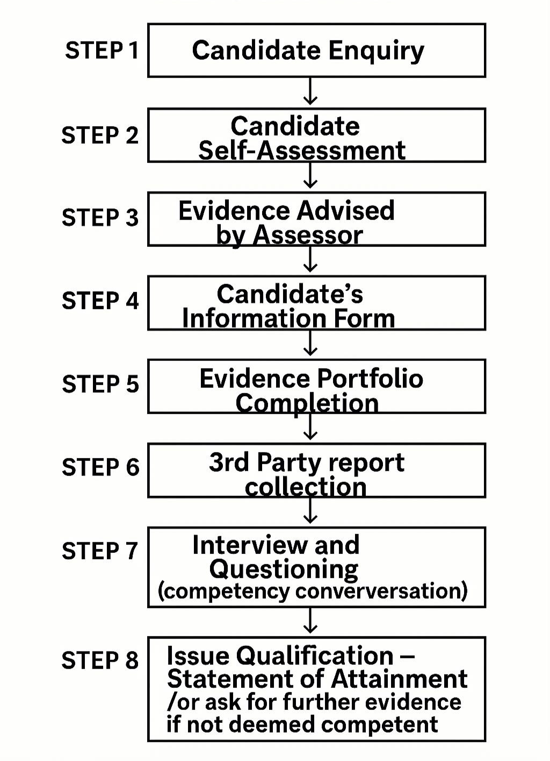

What Evidence is Needed for RPL?
RPL recognizes that skills and knowledge can be gained through work, study, or life experience. Candidates must provide evidence to show their competence, which may include:
- Indirect Evidence:
Documents, products, certificates, reports, or media files produced by the candidate.
- Supplementary Evidence:
Information from written/oral questions, off-the-job tests, or third-party reports (e.g., from supervisors or colleagues).
Examples of Evidence:
- Work records, training journals, resumes/CVs
- Certificates, statements of attainment, assessment results
- Workplace training records, skills/knowledge assessments
- Photos or videos of tasks performed
- Evidence of unpaid or volunteer work
- Work samples, third-party reports, performance appraisals, position descriptions
A strong RPL application usually combines several types of evidence into a “Portfolio of Evidence.” may also require practical assessments to confirm current competence.
Note:
For credit transfers, copies of qualifications must be certified by a Justice of the Peace or verified by a staff member. If you’re unsure about your evidence, discuss your options with your assessor.

RPL Candidate Instructions
This RPL assessment pack is to be used in accordance with the following Virtual RTO documents:
- Assessment Policy
- Pre-enrolment and Student Support Policy

RPL Candidate Evidence Tool Overview
Candidate’s name
Unit code and name
Application no.

A Note to Potential RPL Candidates About This Unit
This unit requires that you have:
on three occasions prepare, create and finalise an electronic presentation.

During the above, you have:
- followed relevant ergonomic requirements and organisational policies and procedures
- adhere to task requirements and organisational policies and procedures relating to:
- following designated timelines
- consistency of design and layout
- editing and style requirements
- use relevant help functions to rectify presentation issues
- produce presentation in appropriate format
- store presentation in accordance with organisation policies and procedures relating to data security.
You also must demonstrate knowledge of:

- design features and their effect on the readability and appearance of electronic presentations
- key functions of relevant applications for producing electronic presentations
- organisational requirements for ergonomics
- key features of organisational style and presentation guide

Part A: Self-Assessment and Application Documents

Candidate Instructions
- Complete the Self-Assessment Checklists.
- Summarise the units you want to complete and how you will complete them in the Qualification Summary (provided separately).
- Fill out the RPL Application Form (provided separately).
- Gather Application Evidence to complete your application.
- Return Part A to our office.

How to Use the Self-Assessment Checklists (For RPL Candidate)
- Use to determine whether RPL is a suitable option for you for this unit.
- Go through the checklists, look at the statements and respond to them by ticking what you can and cannot do.
- Give yourself an honest skill rating from 1 (been the lowest) to 4 (been the highest).
- Reflect upon your ability to provide recent evidence to support your RPL claim. Evidence should not be more than 12 months.
- If you answered ‘Yes’ to every item and gave yourself an average skill rating between three and four, it is recommended that you pursue RPL for that unit.
- There is an Evidence Brainstorm area provided so that you can note any ideas you have about your specific evidence and record your thoughts about the possible options for evidence that you may provide. Use these notes when discussing these options with the assessor.
- Submit copies of your Self-Assessment Checklists to our office, along with your CV and certified copies of your qualifications.

RPL Self-Assessment Checklists

Skill Rating Scale
1 = I always need support with this. |  |  | 2 = I occasionally need support with this.
3 = I am good at this and rarely need support with it. |  |  | 4 = I never need support with this and can do it very well.
I can do the following. |  |  |  | Yes |  | No | Skill Rating  (1, 2, 3, 4)
1. I follow relevant ergonomic requirements and organisational policies and procedure in relation to presentations.
2. I know my organisation’s policies and procedures relate to communication and presentation
3. I follow designated timelines for presentation at the workplace.
4. I am aware of requirements for consistency of design and layout
5. I am proficient in editing and how to follow style requirements
6. I use help effectively functions in PowerPoint or other presentation software.
I can answer questions about the following.
- following designated timelines
- consistency of design and layout
- editing and style requirements
- following designated timelines
I can provide evidence of my ability to do the following: |  |  |  |  |  | Yes | No
- create and finalise an electronic presentation
- follow relevant ergonomic requirements and organisational policies and procedures
- adhere to task requirements and organisational policies and procedures relating to:
- following designated timelines
- consistency of design and layout
- editing and style requirements

Evidence Brainstorm
Other Evidence to Gather |  |  |  |  | (Assessor Use Only)  Candidate to Provide?

Should I apply for RPL for this unit?
Think about your responses above. Based on your self-assessment and your ability to gather the required evidence for this unit, should you apply for RPL?
- Yes | - No | - Unsure (if so, talk to your assessor)
Candidate’s signature:

Part B

Task 1: Evidence Tasks

Candidate Instructions
Important!
Do not begin these Evidence Tasks until you have met with your assessor and determined whether you can apply for the units included in this kit. Any observation tasks will require your assessor to organise a time with you and your workplace supervisor (where tasks must be completed in your workplace).

Portfolio of Evidence
- Carefully consider the documentation and items of evidence you include.
- Ensure privacy and confidentiality are maintained for individuals and the workplace by removing identifying names or images as required and asking for permission before submitting workplace documents.
- You may include meeting professional development trainings, and workplace training sessions or workshops.
- Please note: It is not important if the names of the documents listed do not match those that your organisation uses—the intent and purpose of the documentation are what are important to your RPL application.

Task 2: Verbal Questioning
The purpose of the verbal questions is for your assessor to ensure that your knowledge and experience align with the written evidence that you have provided. The questions ensure that you have the required knowledge and skills and the authenticity of your submitted evidence.
- Once we have your documentary evidence, your assessor will ask you some verbal questions.
- Questioning may occur in person, over the phone or in an online meeting.
- Questions may cover the following areas:
- descriptions of past experiences you have had that relate to the unit(s)
- your knowledge of applicable legislation, regulations, codes of practice, standards, licensing and so on
- how you respond to or deal with specific situations
- use of specific industry terminology
- how you apply workplace policies and procedures to your work
- the equipment, tools, machinery, materials, resources and technologies that you use that relate to the unit
- ensure that you are familiar with the relevant topics – refer to the Self-Assessment Checklists for guidance
- items in your Evidence Portfolio.

Task 3: Third-Party Reports
- In most cases, workplace skills and performance confirmation from people you have worked with will be required.
- When required, RPL Third-Party Reports are to be completed by those with whom you have recently worked.
- Third-party representatives should be people who have worked in a supervisory capacity to you and/or at the same level or higher to you.
- Discuss your choice of third-party representatives with your assessor. They can advise if you have chosen the right people.
- Reports will be provided in a separate document.

Evidence Tasks for This Unit
Gather the following documentation for this unit and provide this evidence to your assessor for review.
Tick each item once you have added it to your Evidence Portfolio. Assign each item a reference number and add these to the ‘Evidence Register #’ column.
Evidence Tasks | Can I Provide This? |  | Evidence  Register #
Evidence Tasks | Yes | No | Evidence  Register #

Task 1: Portfolio
Part 1: Presentation files
You must submit a portfolio that includes 3 electronic presentations (e.g.: PowerPoint slides used in 3 different occasions).

Part 2: Reflection including:
During preparation of the presentations above, how did you:
- Followed relevant ergonomic requirements and organisational policies and procedures
- adhere to task requirements and organisational policies and procedures relating to:
  - following designated timelines
  - consistency of design and layout
  - editing and style requirements
- use relevant help functions to rectify presentation issues, while using tools/software for presentation creation.
- produce presentation in appropriate format in accordance to audience requirements.
- store presentation in accordance with organisation policies and procedures relating to data security.

Task 1: Evidence
Indicate the evidence that you are submitting for this task (include document names):

Task 2: Verbal Questioning
After you have submitted the above evidence, your assessor will arrange a time to speak with you to ask you the following questions. Your assessor will note the summary of your responses in the assessor notes.

1. Name two design features and their effect on the readability and appearance of electronic presentations, you used during preparation of the above presentations.

Assessor notes:

2. Name any 2 (two) key functions of applications you use for producing electronic presentations.
Assessor notes:

3. Outline two (2) organisational requirements for ergonomics while presenting electronic presentations.
Assessor notes:

4. Identify three (3) key features of organisational style and presentation guide based on your organisation’s communication policy and procedures.
Assessor notes:

Task 3: Third-Party Report

Candidate Instructions
- Provide the following section to your third-party person or persons.
- Ensure that they read the instructions and complete the checklist that follows.

Third-Party Report
Thank you for agreeing to complete this RPL Third-Party Report, which will contribute to evidence for the Recognition of Prior Learning (RPL) process the candidate is currently undertaking for BSBTEC303 Create electronic presentations.

Application of This Unit
This unit describes the skills and knowledge required to design and produce electronic presentations using various applications and platforms.
The unit applies to individuals employed in a range of work environments who design electronic presentations. They may work as individuals providing administrative support within an enterprise or may be responsible for production of their own electronic presentations.
No licensing, legislative or certification requirements apply to this unit at the time of publication.

Who Should Complete This Report?
This report is to be completed by a person currently working or has previously worked, in a supervisory capacity to the candidate and can confirm their skills and knowledge as relevant to workplace performance. A third-party person may be someone who has worked with the candidate in a work group or team, who has been managed by the candidate (within the past two years) or even a client/ customer.

What Do I Have to Do?
This report includes a checklist for the knowledge and skills that must be confirmed for the candidate to gain RPL for this unit of competency. We ask that you answer the questions related to the candidate’s performance by checking either ‘Yes’ or ‘No’ against each question.

Please add comments describing how you have observed the candidate demonstrate these skills.
You can also record any concerns that you may have about the candidate’s competence.

How Will My Comments Be Used in the Assessment Decision?
There are no right or wrong answers in this report; your perceptions and opinions are important. You are not providing the assessment decision. However, your comments will assist the assessor in forming their final opinion of the candidate’s competence. The candidate will provide a range of evidence to help the assessor to make the final decision.

Instructions
- Please indicate whether you have observed the candidate performing the tasks/items below by marking the relevant checkbox as ‘Yes’ or ‘No’.
- You should consider whether the candidate can do the tasks/items indicated and whether they can do them consistently and to your workplace’s expectations and standards while always following relevant procedures and work processes.
- If you have not seen the candidate perform the tasks/items or do not believe that they can do so, please add comments. Your feedback will assist the assessor in making an assessment decision.
- Add any further comments in the space provided.

Third-Party Checklist

Candidate name:
Can the candidate do the following? |  |  | Yes |  | No
1. Create and finalise an electronic presentation?

2. Follow designated timelines, ergonomic requirements and organisational policies and procedures consistency of design and layout editing and style requirements, use relevant help functions to rectify presentation issues produce presentation in appropriate format store presentation in accordance with organisation policies and procedures relating to data security.

Comments:

Third-Party Declaration
- I work/have worked in a supervisory capacity for the candidate.
- I work/have worked with the candidate at the same level/as a member of the same team or have worked and interacted with the candidate in activities relevant to this unit of competency.
- I have approved the release of workplace documentation (only tick if you work in a supervisory capacity).
I can confirm that the evidence submitted by the candidate for their RPL application is their own (only tick if you work in a supervisory capacity).
What is your relationship to the candidate? In what capacity have you worked and interacted with the candidate?
Name of third party:
Signature of third party: |  | Date:

