Learning Activity Subject

# Measuring and marking timber for cutting

Devise a learning activity for this subject.

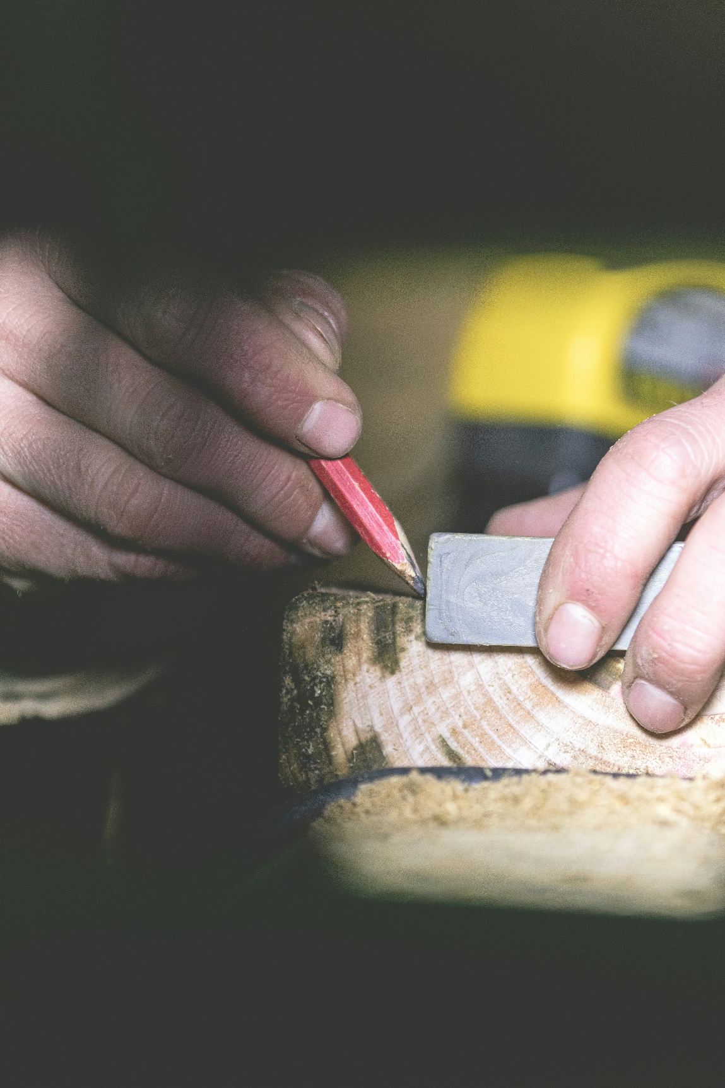

### Images

|  |  |  |  |  |
| --- | --- | --- | --- | --- |
| **Page** | **Description** | **ID/Title** | **Artist** | **Source/**  **License** |
| 1 | A person using a pencil to cut a piece of wood | A person using a pencil to cut a piece of wood | Chandler Cruttenden | Unsplash |